# Putting it on a GUI

* We will use this list and build a GUI around it by combining our starting GUI with this program
* This should be your habit - no point starting from an empty page

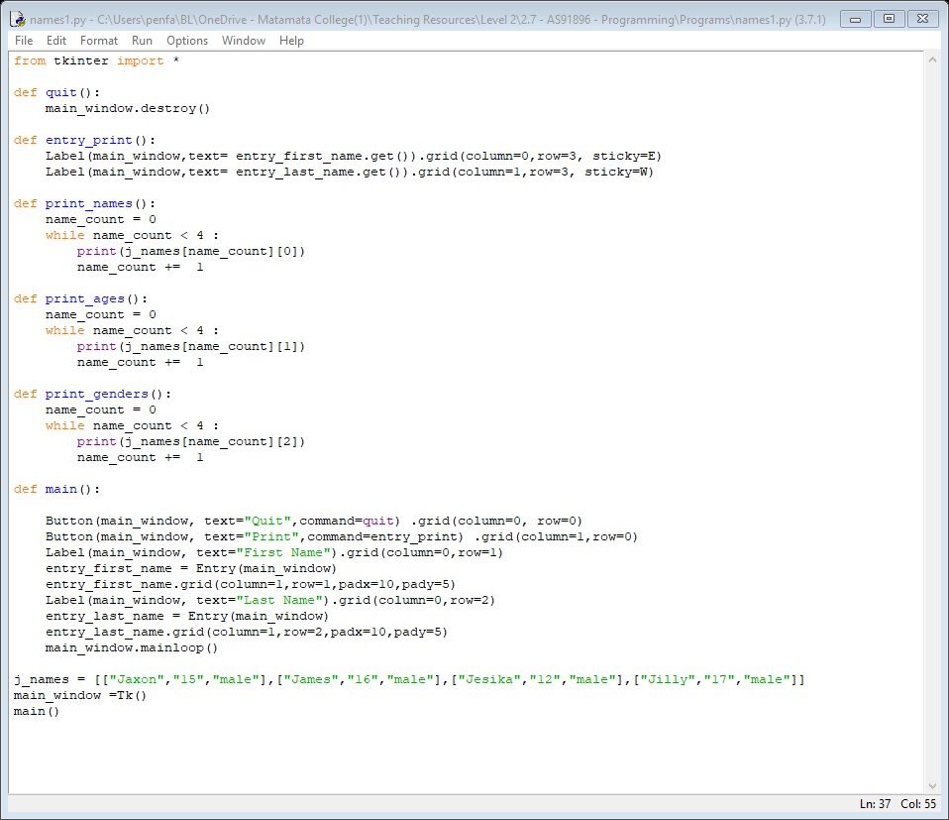

* The program on the previous page will not work as it is just two programs copy/pasted together

task time

* Either copy/pasting two of your own programs, or while typing in the above program, change the variables and buttons to make a workable program
* Don’t look at the example below until you have done your best effort

## Working, basic program

* This program works, but it is not yet very good
* Having a basic program that works should always be your aim. If you try and get the ideal program working from the start you will have a much more difficult task
* Often the best way to start is to just run your program. When you do you will see some clear errors

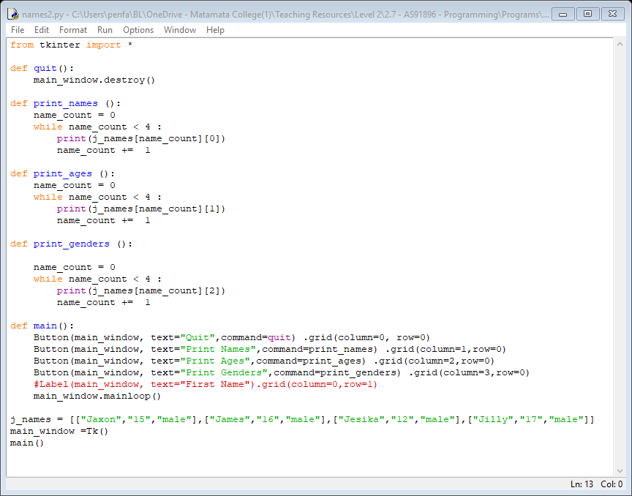

* You may wonder why the Label line has been left in, but commented out
* This is a good idea when you have a line of code you know you will be using/modifying later

Task time

* Tidy up the layout as it is not very well laid out
* Add a button to print off name, age and gender in one row

## putting it on the GUI

* The next step is to put the list onto the GUI; not just printing it out
* We already have all the tools we need to do this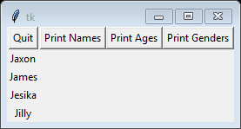

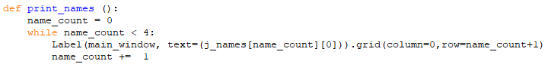

* Note how row is **name_count+1** this is to allow for the buttons at the top

Task time

* Add a column heading for the name
* Change the rest of the columns so they also use labels on the GUI
* Add font=’bold’ to the column headings

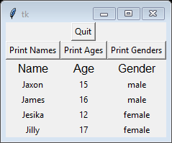

# Appending to a list

* So far, we have only created and then used the list we have created
* Especially with a GUI we can append to a list

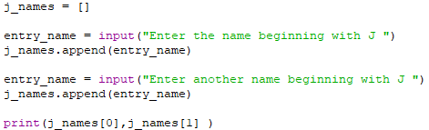

Python 3.7.0 Shell

* You would normally use a loop to continue entering name - with a GUI it is not as important

# appending to a GUI list

* Below is a basic program that appends to a list through a GUI
* It also has a subroutine to print off all the members of the list
* See how when an item is added to the list, the counter is increased with the number of items

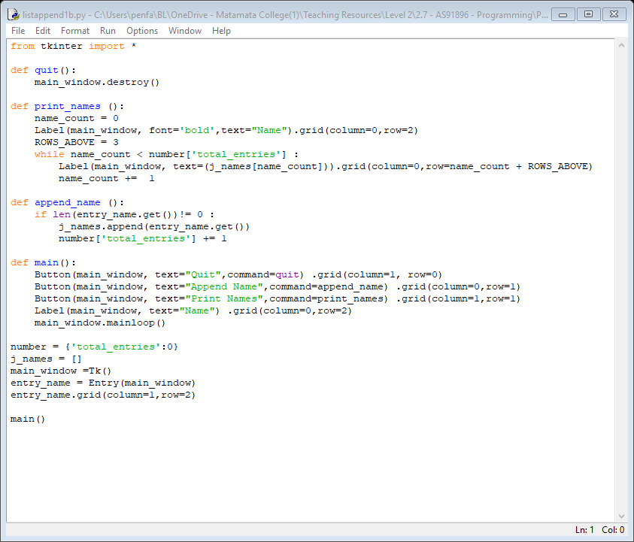 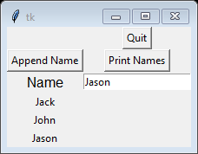

Task time

* You will notice that when you click on append name it does not clear
* Add **entry_name.delete(0,'end')** at a suitable place to fix
* Add back in the age and gender entry boxes from the previous program
* Get the output to print the lines

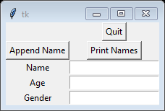

* These two lines of code might help
* **j_names.append([entry_name.get(),entry_age.get(),entry_gender.get()])**
* **print(j_names[0][2],j_names[0][1],j_names[0][0])**
* Next get the GUI to add each line of details as you go

# better program

* This program works pretty well, but could be improved

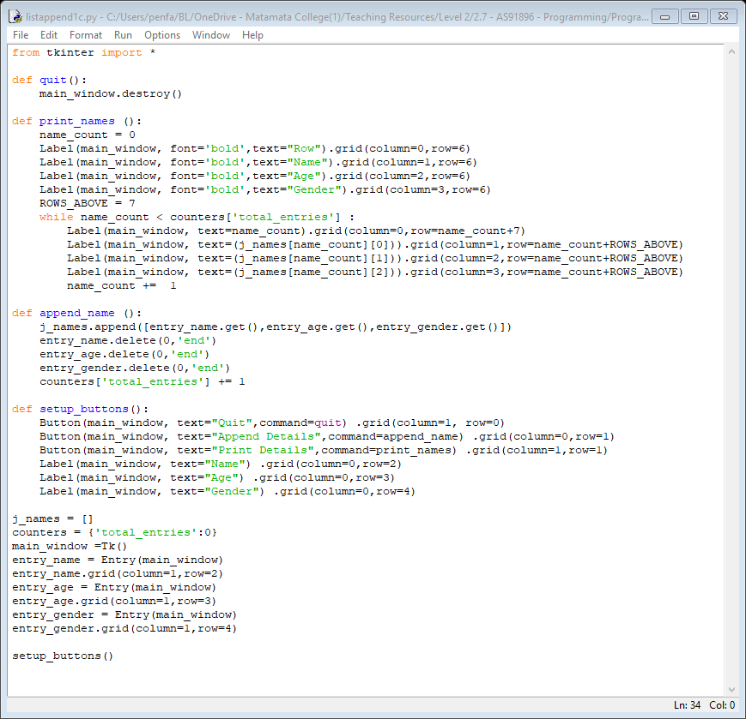 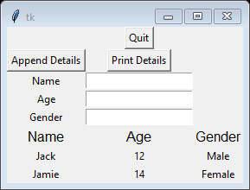

* Notice how the setup of the buttons has been moved to its own subroutine
* This is because it was getting quite complicated. Good programming practice includes separating separate sections into its own subroutine - when it gets this big you need to

Task time

* Add an extra column at the left to include the number in the list such as 0,1,2 etc

# deleting from a list

* To delete item 2 from the list j_names you use **del j_names(2)**  Better is **del j-names(int(2))**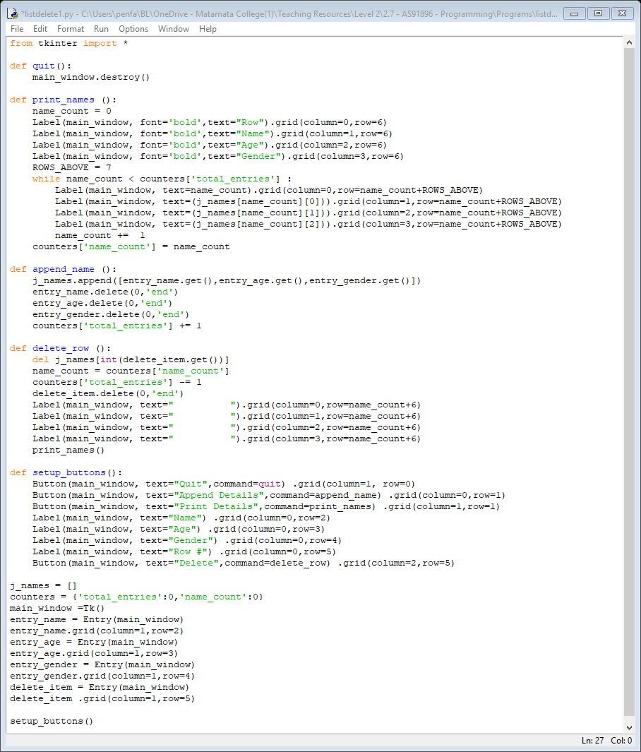

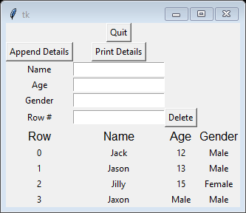

Task time

* The program is working correctly, however, as there is no row 3 it still shows up from when Print Details was pressed the first time
* Fix this issue. Two possible solutions are to delete the label or delete the entire GUI and rebuild it

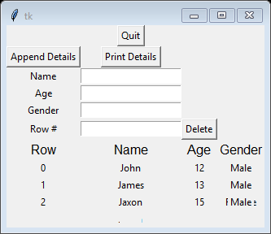

* You can see in row 2 you can still see part of the word female
* Move the quit button so it is in the same row as **append details** and **print details**
* Make other improvements so it looks more attractive